ORDER
OF THE
HOLY MASS

Please Put
Beautiful Picture Here
☺

Epiphany
“Theme”

___ Sunday after Epiphany
MM DD, 20YY

Processional
Please stand

Selection per Parish or Mission
Acclamation
The Ministers face the Presider, while the Presider faces the people and proclaims:
Presider: Blessed be God: Father, Son, and Holy Spirit;
People: And blessed be His Kingdom, now and forever. Amen.
Collect for Purity
Presider: Let us pray.
Clergy face the Altar. Miter off.
Almighty God, to You all hearts are open,
all desires known, and from You no secrets are hid.
Cleanse the thoughts of our hearts ✠
by the inspiration of Your Holy Spirit,
that we may perfectly love You
and worthily magnify Your holy Name;
through Christ our Lord.

All: Amen.

Penitential Rite
The Summary of the Law and the Invitation to Confession are spoken by the Deacon in a high mass.
Deacon faces the people.
Summary of the Law
Deacon: Jesus said, “The first Commandment is this:
Hear, O Israel: the Lord our God, the Lord is one. Love the Lord Your God with all your heart, with all your soul, with all your mind, and with all your strength.
The second is this: Love your neighbor as yourself. There is no other commandment greater than these.
Deacon: Dearly beloved, let us come into the presence of the Almighty God, praying together as we kneel:
Deacon faces the Altar. All kneel. Deacon leads the prayer, in unison:
Confession
All: Most merciful God, I confess that I have sinned against You in thought, word, and deed, by what I have done, and by what I have left undone. I have not loved You with my whole heart; I have not loved my neighbor as myself. I am truly sorry and I humbly repent. For the sake of Your Son Jesus Christ, have mercy on me and forgive me; that I may delight in Your will, and walk in Your ways, to the glory of Your Name. Amen.

Absolution
Presider faces the people.
Presider: Almighty God have mercy on you, ✠ forgive you all your sins through our Lord Jesus Christ, strengthen you in all goodness, and by the power of the Holy Spirit keep you in eternal life.
All: Amen.
Please stand

Glory in the Highest (Gloria in Excelsis)
The Presider censes the Altar and then the Deacon of the Mass censes the Ministers.
Arrangement per parish or mission
Collect of the Day Proper _____ CEC
Presider faces the people.
Presider: The Lord be with you.
People: And with your spirit.
Presider: Let us pray.
Presider and Ministers face the Altar.
The Collect of the Day is taken from the Proper for that Sunday or feast day.

Presider: According to designated Proper

All: Amen.
Presider goes to the back of the Altar, kisses it, and goes to his chair.
Please be seated

Liturgy of the Word
Please be seated
First Proclamation
Proclaimer: A Proclamation of the Word of God from …

According to the designated Proper

Proclaimer: The Word of the Lord.
People: Thanks be to God!
Please stand
Responsorial Psalm:
According to the designated Proper

Proclaimer: Please stand for the Responsorial Psalm, which
- today is … (if the entire psalm is read)
- is taken from … (if only a portion of the psalm is read)

All stand and the Proclaimer leads the people in the Responsorial Psalm followed by the Gloria Patri.
Gloria Patri (BCP, Rite II)
The Gloria Patri may be spoken or sung in unison. The Proclaimer and Altar Ministers remain in their places, face the Altar, and bow.
All: Glory to the Father, and to the Son, and to the Holy Spirit: ✠
As it was in the beginning, is now, and will be forever. Amen.
A Choral Response may be sung here.

Selection per Parish or Mission

Please be seated
Second Proclamation
Proclaimer: A Proclamation of the Word of God from …
According to the designated Proper
The proclaimer reads the second appointed lesson of the day.
Proclaimer: The Word of the Lord.
People: Thanks be to God!
Please stand.
Gradual Verse
Proclaimer: According to the designated Proper

Miter On. Bless the Gospel Proclaimer.
Gradual Hymn

Selection per Parish or Mission

Gospel Acclamation
Miter Off.
Deacon: The Lord be with you.
People: And with your spirit.
Deacon: May the Lord be on our ✠ minds, on our ✠ lips, and on our ✠ hearts as we hear ✠ His Holy Gospel.
The Holy Gospel of our Lord Jesus Christ according to Saint ….
People: Glory to You, Lord Christ!

Gospel Proclamation
The appointed Gospel is read by a Deacon.
According to the designated Proper

Deacon: The Gospel of the Lord.
People: Praise to You, Lord Christ!
All sit.
Homily
Please stand

Nicene Creed
All: We believe in one God, the Father Almighty, Maker of Heaven and earth, and of all things: visible and invisible.
And in one Lord, Jesus Christ, the only begotten Son of God, begotten of His Father before all worlds;
God of God, Light of Light, very God of very God
begotten, not made, being of one substance with the Father;
by Whom all things were made;
Who for us men and for our salvation came down from Heaven;
and was incarnate by the Holy Spirit and the Virgin Mary, and was made man;
And was crucified also for us under Pontius Pilate;
He suffered death and was buried, and rose again on the third day, in accordance with the Scriptures;
and ascended into Heaven, and is seated on the right hand of the Father;
and He shall come again, with glory, to judge the living and the dead;
Whose Kingdom shall have no end.
And we believe in the Holy Spirit the Lord, and Giver of Life, Who proceeds from the Father;
Who with the Father and the Son together is worshiped and glorified;
Who has spoken through the prophets.
And we believe one holy catholic and apostolic Church;
We acknowledge one baptism for the remission of sins;
and we look for the resurrection of the dead, and the life of the world to come. Amen. ✠

Prayers of the People Form VI (CEC)
The Deacon begins the Prayers of the People. The Minister continues.
Deacon: In peace, we pray to You, Lord God.

Minister: For all people in their daily life and work;
People: For our families, friends, and neighbors, and for those who are alone.

Minister: For this community, the nation, and the world;
People: For all who work for justice, freedom, and peace, especially President Duterte.

Minister: For the just and proper use of Your creation;
People: For the victims of hunger, fear, injustice, and oppression.

Minister: For all who are in danger, sorrow, or any kind of trouble;
People: For those who minister to the sick, the friendless, and the needy.

Minister: For the peace and unity of the Church of God;
People: For all who proclaim the Gospel, and all who seek the Truth.

Minister: For Craig our Patriarch, Ariel our Bishop, and for all bishops and other ministers;
People: For all who serve You in Your Church.

Minister: For all who have died,
People: That they may have a place in Your eternal Kingdom.

Minister: Hear us, Lord;
People: For Your mercy is great.

Minister: We thank You, Lord,
People: For all the blessings of this life.

Minister: We exalt You, O God our King;
People: And praise Your Name forever and ever.

Minister: Lord, let Your lovingkindness be upon us;
People: We put our trust in You, as we lift to You our Corporate Petition.

Corporate Petition
Almighty God and King,
our dwelling place in all generations,
owner of the earth and all it contains:
Grant unto us our allotted inheritance, we pray,
and the grace to build upon it
facilities in which Your people,
being restored in Your image
and ever-growing in love for You,
might become a habitation of Your presence
and ministers of Your life,
to the glory of Jesus Christ our Lord;
Who lives and reigns together with You
and the Holy Spirit, one God,
now and forever. Amen.

Alternatively, the Prayers of the Faithful included in the Proper for this Sunday or other feast may be prayed instead.

Refer to the Proper provided.

Corporate Petition

Concluding Collect

Presider: According to the designated Proper
All: Amen.

Peace

Presider: The peace of the Lord be always with you.

People: And with your spirit.
Presider: Let us offer one another a sign of God’s peace.

Offertory
Presider gives the Offering Exhortation.

Worship in Psalms,
Hymns,
and Spiritual Songs:
The Sacrifice
of Praise

The Offertory:
The Sacrifice
of Ourselves

Selection per parish or mission
The Lesser Doxology may be sung in a high mass, during which time the Presider censes the gifts.
After the Altar and Gifts have been censes by the Presider, the Deacon censes the Ministers, then all of the people.
Then Presider censes the front of the Altar and the Ministers again.

Lesser Doxology
(Traditional)
(Words and Music By: Thomas Ken)
(Attributed To Louis Bourgeois)

Praise God from Whom all blessings flow,
Praise Him all creatures here below;
Praise Him above, ye heavenly Host:
Praise Father, Son and Holy Ghost!
AMEN!

Preparation of the Gifts
Standing behind the Altar, the Presider takes the paten with the bread or a large host, and, holding it slightly raised above the altar, says:
Presider: Blessed are You Lord, God of all creation. For through Your goodness we have received the bread we offer You: fruit of the earth and work of human hands, it will become the Body of Christ.
People: Blessed be God forever.
While pouring a small amount of water into the chalice and flagon, the Presider says quietly:
Presider: By the mystery of this water and wine may we come to share in the divinity of Christ, who humbled Himself to share in our humanity.
Then the Presider takes the chalice and, holding it slightly raised above the altar, says:
Presider: Blessed are You Lord, God of all creation, for through Your goodness we have received the wine we offer You, fruit of the vine and work of human hands; it will become the Blood of Christ.
People: Blessed be God forever.

Then the Presider takes an offering basket or bag, and while holding it slightly raised above the altar, says:
Presider: Blessed are You Lord, God of all creation, for through Your goodness we bring these tithes and offerings before You. They will be used in Your church for the work You have set before us and the furthering of Your kingdom.
Presider places the offering below the altar, then washes his hands, quietly saying:
Presider: Wash me, O Lord, from my iniquity and cleanse me from my sin.
Exhortation To Pray (Orate fratres)
The Presider returns to the center of the altar, faces the people, and says:
Presider: Pray, brothers and sisters, that our sacrifice may be acceptable to God, the Almighty Father.
People: May the Lord accept the sacrifice at your hands for the praise and glory of His name, for our good and the good of all His holy Church.
All: Amen.

Great Thanksgiving
Presider: The Lord be with you.
People: And with your spirit.
Presider: Lift up your hearts.
People: We lift them up to the Lord.
Presider: Let us give thanks to the Lord our God.
People: It is right to give Him thanks and praise.
Preface ____ Ordinary CEC
The priest continues the preface with hands extended:
Presider: According to the designated Proper

Sanctus Benedictus

Eucharistic Prayer II CEC
Epiclesis

Please kneel

The Presider joins his hands, then, holding them outstretched over the offerings, says:

Presider: You are indeed holy, O Lord, the fount of all holiness. Make holy, therefore, these gifts, we pray, by sending down Your Spirit upon them like dewfall,

The Presider joins his hands, then makes the sign of the cross once over both bread and chalice, and says:

Presider: so that they may become for us the ✠ Body and Blood of our Lord, Jesus Christ.

Anamnesis

Presider: Before He was given up to death, a death He freely accepted, He took bread and gave You thanks. He broke the bread, gave it to His disciples, and said,

“Take, eat: this is My body, which is for you; do this for the remembrance of Me.”

The Presider shows the consecrated host to the people, places it on the paten, and bows or genuflects in adoration.

Presider: When supper was ended, He took the cup. Again He gave You thanks and praise, gave the cup to his disciples, and said:

“Drink this, all of you. This is My Blood of the New Covenant, which is shed for you and for many for the forgiveness of sins. Whenever you drink it, do this for the remembrance of Me.”

(The Presider shows the consecrated chalice to the people, places it on the corporal, and bows or genuflects in adoration.)

(Please stand)

Mysterium Fidei

Presider: Let us proclaim the mystery of faith.

All: Christ has died, Christ is risen, Christ will come again!

Oratio Pro Ecclessia

Presider: In memory of His death and resurrection, we offer You, Father, this life-giving bread, this saving cup. We thank You for counting us worthy to stand in Your presence and serve You. Humbly we pray that, partaking of the Body and Blood of Christ, we may be gathered into one by the Holy Spirit.

Presider: Lord, remember Your church throughout the world; make us grow in love, together with our Patriarch Craig, our Bishop Ariel, and all the clergy.

Remember those for whom we now pray: _____________________.

Draw our hearts to remember the poor and broken. As we receive the Body and Blood of Jesus may we be transformed to become the Body of Christ to the world.

Have mercy on us all; make us worthy to share eternal life with Blessed Mary, the mother of our Lord and Savior Jesus Christ, Joseph, her husband, and with the apostles, martyrs, and all the saints.

We praise You in union with them and give You glory through Your Son, Jesus Christ.

The Presider takes the chalice and the host and, lifting them up, says:

Presider: By Him, with Him, and in Him, in the unity of the Holy Spirit, all honor and glory is Yours, almighty Father, now and forever.

All: Amen.

The Presider continues:
Presider: And now as our Savior Christ taught us, we are bold to pray.
THE LORD’S PRAYER

Our Father, Who art in heaven,
Hallowed be Thy Name;
Thy kingdom come;
Thy will be done on earth as it is in heaven.
Give us this day our daily bread.
And forgive us our trespasses,
As we forgive those who trespass against us.
And lead us not into temptation,
But deliver us from evil.
For Thine is the Kingdom, and the power,
And the glory; forever, and ever.
AMEN. ✠

Breaking of the Bread
The Presider breaks the consecrated host in half, then breaks off a small piece and places it in the chalice.
Christ our Passover (Pascha Nostrum)
The Christ our Passover (Pascha Nostrum) may be spoken or sung in unison, or antiphonally by the Presider and the People.
Presider: Hallelujah!
Christ our Passover is sacrificed for us!
People: Therefore, let us keep the feast. Hallelujah!
- or – Pascha Nostrum
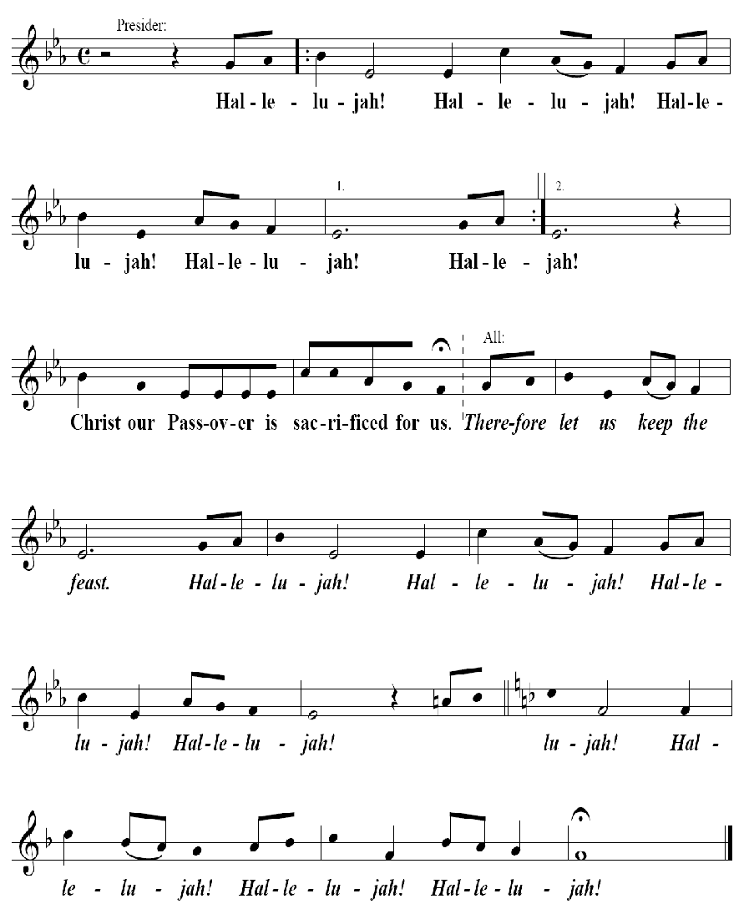

Invitation to Communion
The Presider elevates the host and the chalice together, saying:
Presider: Behold the Lamb of God, behold Him Who takes away the sin of the world. Blessed are those called to the Supper of the Lamb.
People: Lord, I am not worthy that You should enter under my roof, but say only the word and my soul shall be healed.
Presider: The gifts of God for the people of God:
Take them in remembrance that Jesus died for you, and feed on Him in your hearts with thanksgiving.

Prayer for Receiving Spiritual Communion

All: My Jesus, I believe that You are present in the Most Holy Sacrament. I love You above all things, and I desire to receive You into my soul.
Since I cannot at this moment receive You sacramentally, come at least spiritually into my heart. I embrace You as if You are already there, and unite myself wholly to You. Never permit me to be separated from You. Amen.

The Ministration of Communion

Selection per parish or mission

Post-Communion Prayer
Presider: Let us pray.
All: Almighty and everliving God, we thank You for feeding us with the spiritual food of the most precious Body and Blood of Your Son, our Savior Jesus Christ; and for assuring us in these holy mysteries that we are living members of the Body of Your Son, and heirs of Your eternal kingdom.
And now, Father, send us out to do the work You have given us to do, to love and serve You as faithful witnesses of Christ our Lord.
To him, to You, and to the Holy Spirit, be honor and glory, now and forever. Amen.
Blessing
Miter on.
Bishop: The Lord be with you.
People: And with your spirit.
Bishop: Our help is in the Name of the Lord.
People: The maker of heaven and earth.

Deacon: Bow your heads and pray for God’s blessing.
Presider: May Christ, the Son of God, be manifest in you, that your lives may be a light to the world; and the blessing of God Almighty: ✠ the Father and the Son and the Holy Spirit, be with you now and forever. Amen.

OR

Bishop: Remember the Gospel. God was in Christ Jesus reconciling the world to himself, not counting men’s sins against them. God loves you. God has forgiven you. God is not angry at you. And God will never leave you, nor forsake you. And the blessing of God Almighty, the Father ✠ and the Son ✠ and the Holy Spirit ✠ be with you this day and forever.

Recessional
Selection per parish or mission.
Dismissal
Deacon: Go in peace glorifying the Lord by your life.
People: Thanks be to God. Hallelujah! Hallelujah! Amen. ✠

