ORDER
OF THE
HOLY MASS
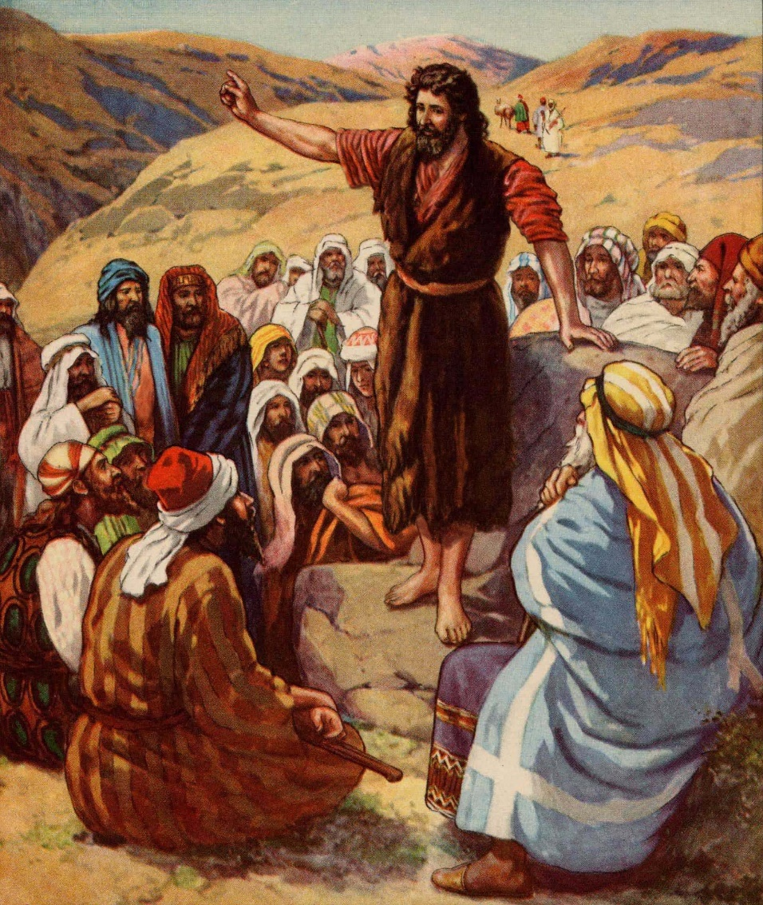
Season of Advent

“Proclamation Of
Immanuel”

4th Sunday of Advent
December 22, 2019
Processional
Please stand

HOLY IS THE LORD
(Fr. Dino Jorvina; c. Cathedral of the King)

Verse)
Holy is the Lord! God eternal we adore;
He is Wonderful, Counselor,
Mighty God, Everlasting Father, the Prince of Peace.
He reigns forever; He comes to save.

Chorus)
Holy! Holy! Holy is the Lord!

Bridge)
There’s a voice in the wilderness crying,
“Prepare the way of the Lord!
Every valley shall be exalted,
every lofty hill brought low;
And the glory of the Lord shall be revealed,
and all flesh shall see, see it!”

End)
Holy is the Lord!!!

Acclamation
The Ministers face the Presider, while the Presider faces the people and proclaims:
Presider: Bless the Lord Who forgives all our sins;
People: His mercy endures forever. Amen.
Collect for Purity
Presider: Let us pray.
Clergy face the Altar. Miter off.
Almighty God, to You all hearts are open,
all desires known, and from You no secrets are hid.
Cleanse the thoughts of our hearts
by the inspiration of Your Holy Spirit,
that we may perfectly love You
and worthily magnify Your holy Name;
through Christ our Lord.

All: Amen.

Penitential Rite
The Decalogue is spoken by the Deacon and the people.
Deacon faces the people.
Decalogue
Deacon: And God spoke all these words: I am the Lord your God, who brought you out of Egypt, out of the land of slavery. You shall have no other gods before Me.
People: Lord, have mercy upon us, and incline our hearts to keep this law.
Deacon: You shall not make for yourself an idol in the form of anything in Heaven above or on the earth beneath or in the waters below. You shall not bow down to them or worship them.
People: Lord, have mercy upon us, and incline our hearts to keep this law.
Deacon: You shall not misuse the Name of the Lord Your God, for the LORD will not hold anyone guiltless who misuses His Name.
People: Lord, have mercy upon us, and incline our hearts to keep this law.
Deacon: Remember the Sabbath day by keeping it holy.
People: Lord, have mercy upon us, and incline our hearts to keep this law.
Deacon: Honor your father and your mother.
People: Lord, have mercy upon us, and incline our hearts to keep this law.

Deacon: You shall not murder.
People: Lord, have mercy upon us, and incline our hearts to keep this law.
Deacon: You shall not commit adultery.
People: Lord, have mercy upon us, and incline our hearts to keep this law.
Deacon: You shall not steal.
People: Lord, have mercy upon us, and incline our hearts to keep this law.
Deacon: You shall not give false testimony against your neighbor.
People: Lord, have mercy upon us, and incline our hearts to keep this law.
Deacon: You shall not covet your neighbor's house, or anything that belongs to your neighbor."
People: Lord, have mercy upon us, and write these Your laws in our hearts.
Deacon: Brethren, let us acknowledge our sins, and so prepare ourselves to celebrate the sacred mysteries.

Deacon faces the Altar. All kneel. Deacon leads the prayer, in unison:
Confession
All: Most merciful God, I confess that I have sinned against You in thought, word, and deed, by what I have done, and by what I have left undone. I have not loved You with my whole heart; I have not loved my neighbor as myself. I am truly sorry and I humbly repent. For the sake of Your Son Jesus Christ, have mercy on me and forgive me; that I may delight in Your will, and walk in Your ways, to the glory of Your Name. Amen.

Absolution
Presider faces the people.
Presider: Almighty God have mercy on you, forgive you all your sins through our Lord Jesus Christ, Strengthen you in all goodness, and by the power of the Holy Spirit keep you in eternal life.
All: Amen.
Please stand

Advent Hymn

THERE'S A VOICE

IN THE WILDERNESS CRYING

1)
There's a voice in the wilderness crying,
A call from the ways untrod;
Prepare in the desert a highway, a highway for our God!
The valleys shall be exalted, the lofty hills brought low;
Make straight all the crooked places
Where the Lord, our God, may go!

2)
O Zion, that bringest good tidings,
Get thee up to the heights and sing!
Proclaim to a desolate people the coming of their King.
Like the flowers of the field they perish,
like grass our works decay;
The power and pomp of nations shall pass like a dream away.

3)
But the Word of our God endureth,
the arm of the Lord is strong!
He stands in the midst of nations, and He will right the wrong.
He shall feed His flock like a shepherd,
the lambs He'll gently hold;
To pastures of peace He'll lead them,
and bring them safe to His fold.

Collect of the Day Proper 4th Advent CEC
Presider faces the people.
Presider: The Lord be with you.
People: And with your spirit.
Presider and Ministers face the Altar.
The Collect of the Day is taken from the preceding Sunday or the preceding feast day, whichever is nearer to the current date.
Presider: Let us pray.
Purify our conscience, Almighty God, by Your daily visitation, that Your Son Jesus Christ, at his coming, may find in us a mansion prepared for himself; Who lives and reigns with You, in the unity of the Holy Spirit, one God, now and forever.
All: Amen.
Presider goes to the back of the Altar, kisses it, and goes to his chair.
Please be seated

Liturgy of the Word
Please be seated
First Proclamation
Proclaimer: A Proclamation of the Word of God from the book of the Prophet Isaiah, Chapter Seven.
Isaiah 7: 10 – 17
Proclaimer: The Word of the Lord.
People: Thanks be to God!

Responsorial Psalm: Psalm 80: 1-7; 17-19
All stand and the Proclaimer leads the people in the Responsorial Psalm followed by the Gloria Patri.
Proclaimer: Please stand for the Responsorial Psalm, which today is Psalm Eighty.
Proclaimer: Oh, give ear, Shepherd of Israel, You who lead Joseph like a flock; You who are enthroned above the cherubim, shine forth!
People: Before Ephraim and Benjamin and Manasseh, stir up Your power Ana come to save us!
Proclaimer: O God, restore us Ana cause Your face to shine upon us, and we will be saved.
People: O Lord God of hosts, how long will You be angry with the prayer of Your people?
Proclaimer: You have fed them with the bread of tears, and You have made them to drink tears in large measure.
People: You make us an object of contention to our neighbors, and our enemies laugh among themselves;
Proclaimer: O God of hosts, restore us and cause Your face to shine upon us, and we will be saved.
People: Let Your hand be upon the man of Your right hand, upon the son of man whom You made strong for Yourself;
Proclaimer: Then we shall not turn back from You; revive us, and we will call upon Your name.
People: O Lord God of hosts, restore us; cause Your face to shine upon us, and we will be saved.

Gloria Patri (BCP, Rite II)
The Gloria Patri may be spoken or sung in unison. The Proclaimer and Altar Ministers remain in their places, face the Altar, and bow.
All: Glory to the Father, and to the Son, and to the Holy Spirit:
As it was in the beginning, is now, and will be forever. Amen.
An Advent Hymn may be sung here.

AWAKE, AWAKE O ZION

1) Awake, awake, O Zion, and clothe yourself with strength,
Shake off your dust and fix your eyes on Him.
For you have been redeemed by the precious blood of Jesus,
And now you sit enthroned with Him.

C) Our God reigns, He is King of all the earth,
Our God reigns, and He’s seated on the throne.
Lift your voice and sing a song of praise,
Our God reigns, the awesome Lord most high.

2) How beautiful the feet are of those who bring good news,
For they proclaim the peace that comes from God.
Rise up you holy nation, proclaim the great salvation,
And say to Zion “Your God reigns”.

3) The watchmen lift their voices, and raise a shout of joy,
For He will come again.
Then all eyes will see the salvation of our God,
For He has redeemed Jerusalem.

BRIDGE)
Emmanuel, Emmanuel, our God is with us now.
Please be seated
Second Proclamation
Proclaimer: A Proclamation of the Word of God from the letter of St. Paul to the Romans, Chapter One.
Romans 1: 1 – 7
The proclaimer reads the second appointed lesson of the day.
Proclaimer: The Word of the Lord.
People: Thanks be to God!
Please stand.
Gradual Verse
Proclaimer: Blessed be the Lord, for not one Word has failed of all His good promises, which He promised through His servants.

Miter On. Bless the Gospel Proclaimer.
Gradual Hymn

ANCIENT WORDS
(Lynn Deshazo; c. Hosanna! Music)

1)
Holy words long preserved
for our walk in this world,
They resound with God’s own heart.
O, let the ancient words impart.
Words of life, words of hope,
give us strength, help us cope.
In this world where’er we roam,
Ancient words will guide us home.

Chorus)
Ancient words, ever true,
changing me and changing you;
We have come with open hearts,
O, let the ancient words impart.

Gospel Acclamation
Miter Off.
Deacon: The Lord be with you.
People: And with your spirit.
Deacon: May the Lord be on our minds, on our lips, and on our hearts as we hear His Holy Gospel.
The Holy Gospel of our Lord Jesus Christ according to Saint Matthew, Chapter One.
People: Glory to You, Lord Christ!

Gospel Proclamation
The appointed Gospel is read by a Deacon.
Matthew 1: 18 – 25

Deacon: The Gospel of the Lord.
People: Praise to You, Lord Christ!
All sit.
Homily
Please stand

Nicene Creed
All: We believe in one God, the Father Almighty, Maker of Heaven and earth, and of all things: visible and invisible.
And in one Lord, Jesus Christ, the only begotten Son of God, begotten of His Father before all worlds;
God of God, Light of Light, very God of very God
begotten, not made, being of one substance with the Father;
by Whom all things were made;
Who for us men and for our salvation came down from Heaven;
and was incarnate by the Holy Spirit and the Virgin Mary, and was made man;
And was crucified also for us under Pontius Pilate;
He suffered death and was buried, and rose again on the third day, in accordance with the Scriptures;
and ascended into Heaven, and is seated on the right hand of the Father;
and He shall come again, with glory, to judge the living and the dead;
Whose Kingdom shall have no end.
And we believe in the Holy Spirit the Lord, and Giver of Life, Who proceeds from the Father;
Who with the Father and the Son together is worshiped and glorified;
Who has spoken through the prophets.
And we believe one holy catholic and apostolic Church;
We acknowledge one baptism for the remission of sins;
and we look for the resurrection of the dead, and the life of the world to come. Amen.

Prayers of the People
The Deacon begins the Prayers of the People. The Minister continues.
Deacon: Beloved in the Lord, all who dwell in the world belong to Him. Let us, then, lift His own before Him in prayer.
Minister: O King of Glory, through Immanuel You dwell with Your people.
People: Grant that Your love be seen in Immanuel and in Your Church.
Minister: In Your love, provide for the poor and destitute.
People: In Your love, support the widow and orphan.
Minister: In Your love, forgive the rebellious.
People: In Your love, dwell with the lonely.
Minister: In Your love, vindicate the oppressed.
People: In Your love, comfort the bereaved.
Minister: In Your love, reveal Your glory to this nation;
People: Through the answering of our Corporate Petition.
Corporate Petition
Almighty God and King,
our dwelling place in all generations,
owner of the earth and all it contains:
Grant unto us our allotted inheritance, we pray,
and the grace to build upon it
facilities in which Your people,
being restored in Your image
and ever-growing in love for You,
might become a habitation of Your presence
and ministers of Your life,
to the glory of Jesus Christ our Lord;
Who lives and reigns together with You
and the Holy Spirit, one God,
now and forever. Amen.
Concluding Collect

Presider: Grant, O Father, that we Your people may ever see the sign of Your presence and be the sign of Your love. We ask this in the Name of Jesus Christ our Lord.
All: Amen.

Peace

Presider: The peace of the Lord be always with you.

People: And with your spirit.
Presider: Let us offer one another a sign of God’s peace.

Offertory
Presider gives the Offering Exhortation.

Worship in Psalms,
Hymns,
and Spiritual Songs:
The Sacrifice
of Praise

The Offertory:
The Sacrifice
of Ourselves

ARISE, SHINE!
(Steven Urspringer & Jay Robinson;
c. Priesthood Publications)

Verse)
Arise, shine, for your light has come.
Arise, shine, for your light has come.

Chorus)
And the glory of the Lord has risen,
The glory of the Lord has come;
The glory of the Lord has risen upon you.
LET THE VALLEYS BE RAISED

Chorus)
Let the valleys be raised and the mountains made low,
Every meadow and field overturn;
Make the pathway straight and the highway run smooth
For the coming of God in our day.

1)
God has come to His people as He promised of old,
He has raised up as Savior in the sight of us all.

2)
You, little child, go before Him like the prophets of old,
Bringing news of His coming by the mercy of God.

3)
God has come like the morning on the darkness of night,
As a light to the people, like the breaking of day.
CELEBRATE HIS GOOD LIFE
(Greg Nelson, John Elliott, Steve Green
and Michael W. Smith;
c. O’Ryan Music, Inc./Birdwing Music/
New Wing Music/Laurel Press)

1)
Let us celebrate our gracious Lord,
Tho’ He was rich, made Himself poor,
Like no other king the world had known before.
Through His poverty we have received
An overflow that longs to reach
Into ev’ry need and fill it joyfully.

Chorus)
We will celebrate His life in us;
We will celebrate with joy.
We will celebrate His life;
We will celebrate His joy;
Celebrate our Lord’s good life.

2)
Let us celebrate our gracious Lord
Who teaches us to give Him more
Than we ever dream’d that we could give before.
For we have become the cheerful ones
Who find our joy when His will is done,
And in giving all, His life in us overcomes.
NO OTHER NAME (Hillsong)

1) One Name holds weight above them all,
His fame outlasts the earth He formed,
His praise resounds beyond the stars,
And echoes in our hearts, the greatest One of all.

2) His face shines brighter than the sun,
His grace as boundless as His love,
He reigns with healing in His wings,
The King above all kings, the greatest One of all.

Chorus) Lift up our eyes, see the King has come,
Light of the world reaching out for us,
There is no other Name, there is no other Name,
Jesus Christ our God.
Seated on high, the undefeated One,
Mountains bow down as we lift Him up,
There is no other Name, there is no other Name,
Jesus Christ our God.

3) Find hope when all the world seems lost,
Behold, the triumph of the cross,
His power has trampled death and grave,
Our life found in His Name, the greatest Name of all.

BRIDGE)
The earth will shake and tremble before Him,
Chains will break as heaven and earth sing,
"Holy is the Name, holy is the Name of Jesus, Jesus, Jesus."

CODA) There is no other Name, there is no other Name,
There is no other Name, there is no other Name, Jesus.

The Lesser Doxology may be sung in a high mass, during which time the Presider censes the gifts.
After the Altar and Gifts have been censes by the Presider, the Deacon censes the Ministers, then all of the people.
Then Presider censes the front of the Altar and the Ministers again.

Lesser Doxology
(Traditional)
(Words and Music By: Thomas Ken)
(Attributed To Louis Bourgeois)

Praise God from Whom all blessings flow,
Praise Him all creatures here below;
Praise Him above, ye heavenly Host:
Praise Father, Son and Holy Ghost!
AMEN!

Preparation of the Gifts
Standing behind the Altar, the Presider takes the paten with the bread or a large host, and, holding it slightly raised above the altar, says:
Presider: Blessed are You Lord, God of all creation. For through Your goodness we have received the bread we offer You: fruit of the earth and work of human hands, it will become the Body of Christ.
People: Blessed be God forever.
While pouring a small amount of water into the chalice and flagon, the Presider says quietly:
Presider: By the mystery of this water and wine may we come to share in the divinity of Christ, who humbled Himself to share in our humanity.
Then the Presider takes the chalice and, holding it slightly raised above the altar, says:
Presider: Blessed are You Lord, God of all creation, for through Your goodness we have received the wine we offer You, fruit of the vine and work of human hands; it will become the Blood of Christ.
People: Blessed be God forever.

Then the Presider takes an offering basket or bag, and while holding it slightly raised above the altar, says:
Presider: Blessed are You Lord, God of all creation, for through Your goodness we bring these tithes and offerings before You. They will be used in Your church for the work You have set before us and the furthering of Your kingdom.
Presider places the offering below the altar, then washes his hands, quietly saying:
Presider: Wash me, O Lord, from my iniquity and cleanse me from my sin.
Exhortation To Pray (Orate fratres)
The Presider returns to the center of the altar, faces the people, and says:
Presider: Pray, brothers and sisters, that our sacrifice may be acceptable to God, the Almighty Father.
People: May the Lord accept the sacrifice at your hands for the praise and glory of His name, for our good and the good of all His holy Church.
All: Amen.

Great Thanksgiving
Presider: The Lord be with you.
People: And with your spirit.
Presider: Lift up your hearts.
People: We lift them up to the Lord.
Presider: Let us give thanks to the Lord our God.
People: It is right to give Him thanks and praise.
Preface 3 Advent CEC
The priest continues the preface with hands extended:
Presider: It is truly right and just, our duty and our salvation, always and everywhere to give You thanks, Lord, holy Father, almighty and eternal God, through Christ our Lord.
For all the oracles of the prophets foretold him, the Virgin Mother longed for him with love beyond all telling and, John the Baptist sang of his coming and proclaimed his presence when He came. It is by his gift that already we rejoice at the mystery of his Nativity, so that He may find us watchful in prayer and exultant in his praise.
And so, with angels and archangels, with thrones and dominions, and with all the hosts and powers of heaven, we sing the hymn of Your glory, as without end we acclaim:
Sanctus Benedictus

Eucharistic Prayer IV CEC
Presider: Holy and gracious Father, in Your infinite love You made us for Yourself, and when we had fallen into sin and become subject to evil and death, You, in Your mercy sent Jesus Christ, Your only and eternal Son, to share our human nature, to live and die as one of us, to reconcile us to You, the God and Father of all.
He stretched out his arms on the cross and offered himself, in obedience to Your will, a perfect sacrifice for the whole world.

Epiclesis
Please kneel
The Presider joins his hands, then, holding them outstretched over the offerings, says:
Presider: And so, Father, we pray that, in Your goodness and mercy, Your Holy Spirit may descend upon us and upon these gifts, sanctifying them and showing them to be holy gifts for Your holy people, the bread of life and the cup of salvation,
The Presider joins his hands, then makes the sign of the cross once over both bread and chalice, and says:
Presider: the Body and Blood of Your Son, Jesus Christ.
Anamnesis
Presider: On the night He was handed over to suffering and death, our Lord Jesus Christ took bread; and when He had given thanks to You, He broke it, gave it to his disciples, and said,
“Take, eat: this is My body, which is for you; do this in remembrance of Me.”
The Presider shows the consecrated host to the people, places it on the paten, and bows or genuflects in adoration.
Presider: After supper He took the cup of wine, and when He had given thanks, He gave it to them and said:
“Drink this, all of you. This is My Blood of the New Covenant, which is shed for you and for many for the forgiveness of sins. Whenever you drink it, do this for the remembrance of Me.”
(The Presider shows the consecrated chalice to the people, places it on the corporal, and bows or genuflects in adoration.)

(Please stand)
Presider: Father, we now celebrate this memorial of our redemption. Recalling Christ’s death and his descent among the dead, proclaiming his resurrection and ascension to Your right hand, and awaiting his coming in glory; and offering to You from the gifts You have given us, this bread and this cup, we give You praise as we proclaim the mystery of faith:

Mysterium Fidei

All: Christ has died, Christ is risen, Christ will come again!

Oratio Pro Ecclessia

Presider: Grant that all who share this bread and cup may become one body and one spirit, a living sacrifice to the praise of Your Name.
Remember, Lord, Your one holy catholic and apostolic Church, redeemed by the blood of Jesus. Reveal its unity, guard its faith, and preserve it in peace.
Remember Craig, our Patriarch, Ricardo our Primate, Ariel our own Bishop, and all who minister in Your church and teach the true faith that comes to us from the apostles.
Remember those for whom we now pray: _____

Presider: And grant that we may find our inheritance with the Blessed Virgin Mary, with Joseph her husband, with patriarchs, prophets, apostles, and martyrs, and all the saints who have found favor with You in ages past. We praise You in union with them and give You glory through Your Son Jesus Christ our Lord.
The Presider takes the chalice and the host and, lifting them up, says:
Presider: By Him, with Him, and in Him, in the unity of the Holy Spirit, all honor and glory is Yours, almighty Father, now and forever.
All: Amen.

The Presider continues:
Presider: And now as our Savior Christ taught us, we are bold to pray.

THE LORD'S PRAYER

(Samuel Thurman)

Our Father, Who art in heaven,
Hallowed be Thy Name;
Thy kingdom come;
Thy will be done on earth as it is in heaven.
Give us this day our daily bread.
And forgive us our trespasses,
As we forgive those who trespass against us.
And lead us not into temptation.
But deliver us from evil.
For Thine is the Kingdom and the power
And the glory forever, forever, forever, forever.
AMEN.
Breaking of the Bread
The Presider breaks the consecrated host in half, then breaks off a small piece and places it in the chalice.
Lamb of God (Agnus Dei)
The Lamb of God (Agnus Dei) may be spoken or sung by all, or antiphonally by the Presider and the People.
Lamb of God, You take away the sins of the world:
have mercy on us.
Lamb of God, You take away the sins of the world:
have mercy on us.
Lamb of God, You take away the sins of the world:
grant us peace.

Invitation to Communion
The Presider elevates the host and the chalice together, saying:
Presider: Behold the Lamb of God, behold Him Who takes away the sins of the world. Blessed are those called to the Supper of the Lamb.
People: Lord, I am not worthy that You should enter under my roof but say only the word and my soul shall be healed.
Presider: The gifts of God for the people of God:
Take them in remembrance that Jesus died for you, and feed on Him in your hearts with thanksgiving.

The Ministration of Communion
YOU ARE NEAR
(Dan Schutte,S.J., c. Danil L. Schutte, SJ)

Chorus)
Yahweh, I know You are near,
standing always at my side.
You guard me from the foe,
and You lead me in ways everlasting.

1)
Lord, You have searched my heart,
and You know when I sit and when I stand.
Your hand is upon me protecting me from death,
keeping me from harm.

2)
Where can I run from Your love?
If I climb to the heavens You are there;
If I fly to the sunrise or sail beyond the sea,
still I find You there.

3)
You know my heart and its ways,
You who formed me before I was born
In the secret of darkness before I saw the sun
in my mother’s womb.

4)
Marvelous to me are Your works;
how profound are Your thoughts my Lord.
Even if I could count them, they number as the stars,
You would still be there.

EMMANUEL

Emmanuel! Emmanuel!
His Name is called Emmanuel.
God with us, revealed in us.
His Name is called Emmanuel.
SEE HIS GLORY
(Rich Cook; c. Hosanna! Music)

See His glory, see His glory.
See His glory come down.
Praise His Name heaven reigns.
See His glory come down.
See His glory come down.

Post-Communion Prayer
Presider: Let us pray.
All: Almighty and everliving God, we thank You for feeding us with the spiritual food of the most precious Body and Blood of Your Son, our Savior Jesus Christ; and for assuring us in these holy mysteries that we are living members of the Body of Your Son, and heirs of Your eternal kingdom.
And now, Father, send us out to do the work You have given us to do, to love and serve You as faithful witnesses of Christ our Lord.
To him, to You, and to the Holy Spirit, be honor and glory, now and forever. Amen.
Blessing
Miter on.
Bishop: The Lord be with you.
People: And with your spirit.
Bishop: Our help is in the Name of the Lord.
People: The maker of heaven and earth.

Deacon: Bow your heads and pray for God’s blessing.
Presider: May He Whose second coming in power and great glory we await make you steadfast in faith, joyful in hope, and constant in love; and the blessing of God Almighty: the Father and the Son and the Holy Spirit, be with you now and forever.
OR
Bishop: Remember the Gospel. God was in Christ Jesus reconciling the world to himself, not counting men’s sins against them. God loves you. God has forgiven you. God is not angry at you. And God will never leave you, nor forsake you. And the blessing of God Almighty, the Father and the Son and the Holy Spirit be with you this day and forever.
.

Recessional
LIFT UP YOUR HEADS
(Steve Fry; c. Birdwing Music)

Verse)
Lift up your heads to the coming King.
Bow before Him and adore Him, sing!
To His majesty let your praises be,
Pure and holy, giving glory to the King of kings.

End)
Pure and holy, giving glory to the King of kings.

Dismissal
Deacon: Go in peace glorifying the Lord by your life.
People: Thanks be to God. Hallelujah! Hallelujah! Amen.

