ORDER
OF THE
HOLY MASS
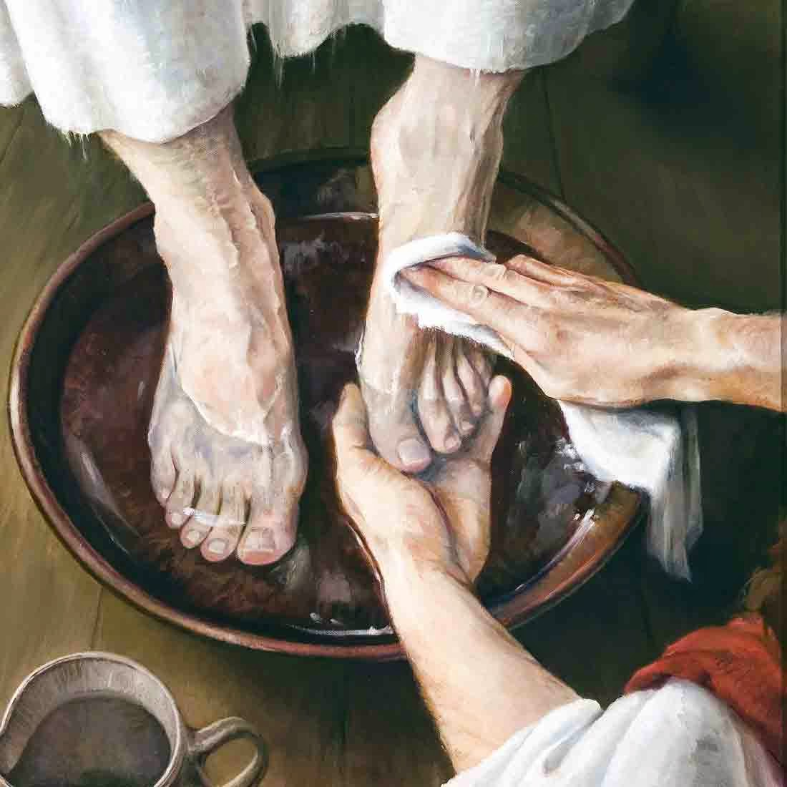
Maundy Thursday
The Glory
of His
Servanthood

Maundy Thursday Mass

April 1, 2021

Processional
Please stand.

BEHOLD THE LAMB
(Words and Music By: Dottie Rambo)
(C 1979 John T. Benson Publishing Company)

Chorus)
Behold the Lamb, behold the Lamb!
Slain from the foundation of the world.
For sinners crucified, O holy sacrifice,
Behold the Lamb of God, behold the Lamb!

Verse)
Crown Him, crown Him, worthy is the Lamb!
Praise Him, praise Him, heaven and earth resound.

Acclamation
The Ministers face the Presider, while the Presider faces the people and proclaims:
Presider: Bless the Lord who forgives all our sins.
People: His mercy endures forever.
Collect for Purity
Presider: Let us pray.
Clergy face the Altar. Miter off.
Almighty God, to You all hearts are open,
all desires known, and from You no secrets are hid.
Cleanse the thoughts of our hearts
by the inspiration of Your Holy Spirit,
that we may perfectly love You
and worthily magnify Your holy Name;
through Christ our Lord.
All: Amen.
Penitential Rite
Deacon: Brothers and sisters, let us acknowledge our sins, and so prepare ourselves to celebrate the sacred mysteries.
Presider and Ministers face the Altar, kneel, and all pray together:
Confession
All: Most merciful God, I confess that I have sinned against You in thought, word, and deed, by what I have done, and by what I have left undone. I have not loved You with my whole heart; I have not loved my neighbors as myself. I am truly sorry and I humbly repent. For the sake of Your Son Jesus Christ, have mercy on me and forgive me; that I may delight in Your will, and walk in Your ways, to the glory of Your Name. Amen.
Absolution
Presider faces the people.
Presider: Almighty God have mercy on you, forgive you all your sins through our Lord Jesus Christ, strengthen you in all goodness, and by the power of the Holy Spirit keep you in eternal life.
All: Amen.
Glory in the Highest (Gloria in Excelsis)
The Presider censes the Altar and then the Deacon of the Mass censes the Ministers.
Glory in the Highest (Gloria in Excelsis) is spoken, not sung.
Glory to God in the highest,
and peace to his people on earth.
Lord God, heavenly King,
almighty God and Father,
we worship You, we give You thanks,
we praise You for Your glory.
Lord Jesus Christ, only Son of the Father,
Lord God, Lamb of God,
You take away the sin of the world:
have mercy on us;
You are seated at the right hand of the Father:
receive our prayer.
For You alone are the Holy One,
You alone are the Lord,
You alone are the Most High,
Jesus Christ, with the Holy Spirit,
in the glory of God the Father. Amen
Collect of the Day Maundy Thursday
Presider faces the people.
Presider: The Lord be with you.
People: And with your spirit.
Presider: Let us pray.
Presider and Ministers face the Altar.
The Collect of the Day for the current Sunday or Feast Day is said.
Presider: Almighty Father, whose dear Son, on the night before He suffered, instituted the Sacrament of His Body and Blood:
Mercifully grant that we may receive it thankfully in remembrance of Jesus Christ our Lord, Who in these holy mysteries gives us a pledge of eternal life; and Who now lives and reigns with You and the Holy Spirit, one God, for ever and ever.
All: Amen.
Presider goes to the back of the Altar, kisses it, and goes to his chair.
Please be seated.
Liturgy of the Word
Please be seated.
First Proclamation
Proclaimer: A Proclamation of the Word of God from the book of Exodus chapter twelve.
Exodus 12: 1 – 8; 11 – 14
Proclaimer: The Word of the Lord.
People: Thanks be to God!

Responsorial Psalm: Psalm 116: 1-2; 12-14; 16
Proclaimer: Please stand for the Responsorial Psalm, taken this evening from Psalm one hundred sixteen.
All stand and the Proclaimer leads the people in the Responsorial Psalm followed by the Gloria Patri.
Proclaimer: I love the Lord, because He hears My voice and my supplications.
People: Because He has inclined His ear to me, therefore I shall call upon Him as long as I live.
Proclaimer: What shall I render to the Lord for all His benefits toward me?
People: I shall lift up the cup of salvation and call upon the name of the Lord.
Proclaimer: I shall pay my vows to the Lord, oh may it be in the presence of all His people.
People: O Lord, surely I am Your servant, I am Your servant, the son of Your handmaid, You have loosed my bonds.

Gloria Patri (BCP, Rite II)
The Gloria Patri may be spoken or sung in unison. The Proclaimer and Altar Ministers remain in their places, face the Altar, and bow.
All: Glory to the Father, and to the Son, and to the Holy Spirit:
As it was in the beginning, is now, and will be forever. Amen.
A Choral Response may be sung here.
Please be seated.

Second Proclamation
Proclaimer: A Proclamation of the Word of God from the letter of St. Paul to the Church at Corinth, chapter eleven.
1 Corinthians 11: 23 – 26
The proclaimer reads the second appointed lesson of the day.
Proclaimer: The Word of the Lord.
People: Thanks be to God!
Please stand.
Gradual Verse
Proclaimer: May Your lovingkindness also come unto me, O Lord, Your salvation according to Your Word.
Miter On. Bless the Gospel Proclaimer.
Gradual Hymn

ANCIENT WORDS
(Lynn Deshazo; c. Hosanna! Music)

1)
Holy words long preserved for our walk in this world,
They resound with God’s own heart.
O, let the ancient words impart.
Words of life, words of hope, give us strength, help us cope.
In this world where’er we roam,
Ancient words will guide us home.

Chorus)
Ancient words, ever true, changing me and changing you;
We have come with open hearts, O, let the ancient words impart.

2)
Holy words of our faith handed down to this age,
Came to us through sacrifice.
O, heed the faithful words of Christ.
Holy words long preserved for our walk in this world,
They resound with God’s own heart.
O, let the ancient words impart.
Gospel Acclamation
Miter Off.
Deacon: The Lord be with you.
People: And with your spirit.
Deacon: May the Lord be on our minds, on our lips, and on our hearts as we hear His Holy Gospel.
The Holy Gospel of our Lord Jesus Christ according to Saint John, chapter thirteen.
People: Glory to You, Lord Christ!
Gospel Proclamation
The appointed Gospel is read by a Deacon.
John 13: 1 – 15
Deacon: The Gospel of the Lord.
People: Praise to You, Lord Christ!
Please be seated.

Homily

Nicene Creed
The Creed is omitted on Maundy Thursday.

Washing of the Feet
The Presider moves to the center of the chancel and says:
Presider : This is the night when we come before the Throne of God and celebrate the Sacrament that Jesus Christ Himself instituted on the first Maundy Thursday. But do we realize what this means?

When our Lord came to that Table in the Upper Room with His disciples almost two thousand years ago, it was to be a celebration of unity: the many heads of grain uniting to become one Loaf; the many grapes donating their substance to become one Cup; the many disciples of Christ joining together into one Body.

But at that very Table the disciples were arguing among themselves over who was the greatest. At that very Table sat the betrayer. How could love be present in the midst of selfishness, jealousy, and every evil work?

So, right there in the middle of the supper, our Lord got up from the Table. He girded Himself as a servant to set an example for His disciples by washing their feet, an act of humble service.

He was teaching that strength, growth, unity and life in the Kingdom of God come not by power, authority, or even miracle, but by such lowly service. We all need to remember His example, for the Lord has called each one of us as ministers in His Kingdom.

Therefore I invite all who share in the priesthood of Christ to watch this scene relived before you, that we may recall Whose servants we are. But remember His admonition that what will be done here is also to be done by you for others, for “a servant is not greater than his master, nor is one who is sent greater than the one who sends him. If you know these things, you are blessed if you do them.”

The Presider washes the feet of seven members of the Church

Prayers of the People
Deacon: Dearly beloved brethren, in this Holy Week we are called to re-examine our lives as Christians, and insure we are following in the footsteps of Christ. Let us pray unto the Lord for grace as we celebrate the Sacrament this evening.
Minister: Almighty and Eternal God, You sent Your beloved Son from Heaven to reconcile us unto You;
People: As we eat His flesh and drink His Blood, grant that we abide in Him, and He in us.
Minister: You sent Your beloved Son from Heaven to become for us wisdom from You;
People: As we eat His flesh and drink His Blood, grant that our eyes be opened in the breaking of the bread.
Minister: You sent Your beloved Son from Heaven to offer Himself for the life of the world;
People: As we eat His flesh and drink His Blood, grant that we walk in eternal life, and bring that life to all mankind.
Minister: You sent Your beloved Son from Heaven not to be served, but to serve;
People: As we eat His flesh and drink His Blood, grant that we be empowered to serve You in His Name.
Concluding Collect
Presider: Let us pray.
Almighty and eternal God, in this Holy Week so return our hearts to You, so guide our minds, so fill our imaginations, so direct our wills, that we may be wholly Yours, utterly dedicated unto You; and then use us, we pray You, as You will, and always to Your glory and the welfare of Your people; through our Lord and Savior Jesus Christ.
All: Amen.

Peace
Presider: The peace of the Lord be always with you.
People: And with your spirit.
Presider: Let us offer one another a sign of God’s peace.

Offertory
Presider gives the Offering Exhortation.
Worship in Psalms,
Hymns,
and Spiritual Songs:
The Sacrifice
of Praise

The Offertory:
The Sacrifice
of Ourselves
According to Parish or Mission

The Lesser Doxology may be sung in a high mass, during which time the Presider censes the gifts. However in Advent and Lent the Presider first censes the Altar.
After the Altar and Gifts have been censes by the Presider, the Deacon censes the Ministers, then all of the people.
The Presider censes the front of the Altar and the Ministers again.

Lesser Doxology
(Traditional)
(Words and Music By: Thomas Ken)
(Attributed to Louis Bourgeois)

Praise God from Whom all blessings flow,
Praise Him all creatures here below;
Praise Him above, ye heavenly Host:
Praise Father, Son and Holy Ghost!
AMEN!
Preparation of the Gifts
Standing behind the Altar, the Presider takes the paten with the bread or a large host, and, holding it slightly raised above the altar, says:
Presider: Blessed are You Lord, God of all creation. For through Your goodness we have received the bread we offer You: fruit of the earth and work of human hands. It will become the Body of Christ.
People: Blessed be God forever.
While pouring a small amount of water into the chalice and flagon, the Presider says quietly:
Presider: By the mystery of this water and wine may we come to share in the divinity of Christ, who humbled Himself to share in our humanity.
Then the Presider takes the chalice and, holding it slightly raised above the altar, says:
Presider: Blessed are You Lord, God of all creation, for through Your goodness we have received the wine we offer You, fruit of the vine and work of human hands; it will become the Blood of Christ.
People: Blessed be God forever.
Then the Presider takes an offering basket or bag, and while holding it slightly raised above the altar, says:
Presider: Blessed are You Lord, God of all creation, for through Your goodness we bring these tithes and offerings before You. They will be used in Your church for the work You have set before us and the furthering of Your kingdom.
Presider places the offering below the altar, then washes his hands, quietly saying:
Presider: Wash me, O Lord, from my iniquity and cleanse me from my sin.

Exhortation to Pray (Orate fratres)
The Presider returns to the center of the altar, faces the people, and says:
Presider: Pray, brothers and sisters, that our sacrifice may be acceptable to God, the Almighty Father.
People: May the Lord accept the sacrifice at your hands for the praise and glory of His name, for our good and the good of all His holy Church.
All: Amen.
Great Thanksgiving
Presider: The Lord be with you.
People: And with your spirit.
Presider: Lift up your hearts.
People: We lift them up to the Lord.
Presider: Let us give thanks to the Lord our God.
People: It is right to give Him thanks and praise.

Preface Holy Thursday CEC
The priest continues the preface with hands extended:
Presider: It is truly right and just, our duty and our salvation, always and everywhere to give You thanks, Lord, holy Father, almighty and eternal God, through Jesus Christ our Lord. He is the true and eternal priest Who established this unending sacrifice. He offered Himself as a victim for our deliverance and taught us to make this offering in His memory.
As we eat His body, which He gave for us, we grow in strength. As we drink His blood, which He pours out for us, we are washed clean. Now, with angels and archangels, and the whole company of heaven, we sing the unending hymn of Your praise:
Sanctus Benedictus

HOLY, HOLY, HOLY
(Lyrics traditional / Music Dcn. Nelson Tantoco;
c. Cathedral of the King)

Holy, Holy, Holy Lord God of Hosts;
Holy, Holy, Holy Lord God of Hosts.
Heaven and earth are full of Thy glory.
Glory be to Thee, O Lord Most High.
Blessed is He that cometh in the Name of the Lord.
Hosanna, Hosanna, Hosanna in the Highest.

Eucharistic Prayer IV CEC
The presider, with hands extended, says:
Presider: Holy and gracious Father, in Your infinite love You made us for Yourself, and when we had fallen into sin and become subject to evil and death, You in Your mercy sent Jesus Christ, Your only and eternal Son, to share our human nature, to live and die as one of us, to reconcile us to You, the God and Father of all. He stretched out his arms on the cross and offered himself, in obedience to Your will, a perfect sacrifice for the whole world.
Please kneel.
Invocation of the Holy Spirit
The Presider raises his hands above the Altar, then lowers them down above the offerings. While making the sign of the cross once over both the bread and chalice, he says:
Presider: And so, Father, we pray that, in Your goodness and mercy, Your Holy Spirit may descend upon us and upon these gifts, sanctifying them and showing them to be holy gifts for Your holy people, the Bread of Life and the Cup of Salvation, the Body and Blood of Your Son Jesus Christ.
The Presider joins his hands.
Words of Institution
The words of the Lord in the following formulas should be spoken clearly and distinctly, as their meaning demands.
Presider: On the night before He died for us, our Lord Jesus Christ took bread; and when He had given thanks to You, He broke it, and gave it to His disciples and said:
“Take, eat: This is My Body, which is given for you. Do this for the remembrance of Me.”
The Presider shows the consecrated host to the people, places it on the paten, and bows or genuflects in adoration.
The Presider continues:
Presider: After supper He took the cup of wine, and when He had given thanks, He gave it to them and said:
“Drink this, all of you: This is My Blood of the New Covenant, which is shed for you and for many for the forgiveness of sins. Whenever you drink it, do this for the remembrance of Me.”
The Presider shows the consecrated chalice to the people, places it on the corporal, and bows or genuflects in adoration.
Please stand.
Please stand.
Mystery of Faith
Then, with hands extended, the Presider says:
Presider: Father, we now celebrate this memorial of our redemption. Recalling Christ’s death and His descent among the dead, proclaiming His resurrection and ascension to Your right hand, and awaiting His coming in glory. Offering to You from the gifts You have given us, this bread and this cup, we give You praise as we proclaim the mystery of faith:
Then all sing or say:
All: Christ has died,
Christ is risen,
Christ will come again.
Prayer for the Church
Then with hands extended, the Presider says:
Presider: Grant that all who share this bread and cup may become one body and one spirit, a living sacrifice to the praise of Your Name. Remember, Lord, Your one holy catholic and apostolic Church, redeemed by the blood of Jesus. Reveal its unity, guard its faith, and preserve it in peace.
Remember Craig our Patriarch, Ariel our own Bishop, and all who minister in Your church and teach the true faith that comes to us from the apostles. Remember those for whom we now pray ___________________.
The Presider prays for them briefly with hands joined. Then, with hands extended, he continues:
Presider: And grant that we may find our inheritance with the Blessed Virgin Mary, with Joseph her husband, with patriarchs, prophets, apostles, and martyrs, and all the saints who have found favor with You in ages past. We praise You in union with them and give You glory
The Presider joins his hands.
Presider: through Your Son Jesus Christ our Lord.
Great Doxology and Great Amen
The Presider takes the chalice and the host, and lifting them up, says:
Presider: By Him, with Him, and in Him, in the unity of the Holy Spirit, all honor and glory is Yours, Almighty Father, now and forever.
The people respond:
People: AMEN.

The Lord’s Prayer
The Presider continues:
Presider: And now as our Savior Christ taught us, we are bold to pray.

THE LORD’S PRAYER
Fr. Danilo M. Jorvina
Our Father, Who art in heaven,
Hallowed be Thy Name;
Thy kingdom come;
Thy will be done on earth as it is in heaven.
Give us this day our daily bread.
And forgive us our trespasses,
As we forgive those who trespass against us.
And lead us not into temptation,
But deliver us from evil.
For Thine is the Kingdom, and the power,
And the glory; forever, and ever.
AMEN.
Breaking of the Bread
The Presider breaks the consecrated host in half, then breaks off a small piece and places it in the chalice.
Lamb of God (Agnus Dei)
The Lamb of God (Agnus Dei) may be spoken or sung in unison, or antiphonally by the Presider and the People.

LAMB OF GOD (AGNUS DEI)

Lamb of God, You take away the sin of the world:
have mercy on us.
Lamb of God, You take away the sin of the world:
have mercy on us.
Lamb of God, You take away the sin of the world:
grant us peace.
Invitation to Communion
The Presider elevates the host and the chalice together, saying:
Presider: Behold the Lamb of God, behold Him Who takes away the sin of the world. Blessed are those called to the Supper of the Lamb.
People: Lord, I am not worthy that You should enter under my roof, but say only the word and my soul shall be healed.
Presider: The gifts of God for the people of God:
Take them in remembrance that Jesus died for you, and feed on Him in your hearts with thanksgiving.

Prayer for Receiving Spiritual Communion

All: My Jesus, I believe that You are present in the Most Holy Sacrament. I love You above all things, and I desire to receive You into my soul.
Since I cannot at this moment receive You sacramentally, come at least spiritually into my heart. I embrace You as if You are already there, and unite myself wholly to You. Never permit me to be separated from You. Amen.

The Ministration of Communion

Worship at the Eucharist (Selection per Parish or Mission)
Post-Communion Prayer
Presider: Let us pray.
All: Almighty and everliving God, we thank You for feeding us with the spiritual food of the most precious Body and Blood of Your Son, our Savior Jesus Christ; and for assuring us in these holy mysteries that we are living members of the Body of Your Son, and heirs of Your eternal kingdom.
And now, Father, send us out to do the work You have given us to do, to love and serve You as faithful witnesses of Christ our Lord.
To him, to You, and to the Holy Spirit, be honor and glory, now and forever. Amen.
Blessing and Dismissal
The Blessing is omitted on Maundy Thursday.

The Mass proceeds immediately to the Stripping of the Altar in silence.
Stripping of the Altar
When two or more act together, they enter from the side to which they are going. They bow and then do as indicated below. Afterwards they bow again and exit on the same side they entered.
1. Acolyte extinguishes the two Altar Candles, then the Sacred Candle.
3. Deacon of the Mass removes the chalice and hands it to an Acolyte.
2. Deacon of the Mass removes the offering bags and hands them to the Sacristan.
4. Bishop goes to the Tabernacle and opens it. He hands the following to the priests:
a. Ciborium – Fr. ??
b. Chrism Oil – Fr. ??
c. Healing Oil – Fr. ??
5. Acolytes remove the torches and processional cross, together with the three bases, as well as the flowers in front of the Lectern.
6. Three deacons remove the Altar Candles and the Sacred Candle.
a. Epistle Side Candle
b. Gospel Side Candle
c. All Life Is Sacred Candle
7. Two priests take the Dust Cover. After they fold it, the priest on the Gospel side takes it to the Vestry as he exits.
8. Two priests take the Altar Cloth. After they fold it, the priest on the Gospel side takes it to the Vestry as he exits.
9. Deacons cover the furniture:
a. Pulpit (1) | b. Lectern (1) | c. Presider’s Chair (1)
10. Deacons cover the Altar.
11. Bp. Ariel goes to the center in front and contemplates the scene, bows and / or kneels, and eventually exits.
12. Lights are turned off.

