Holy Saturday
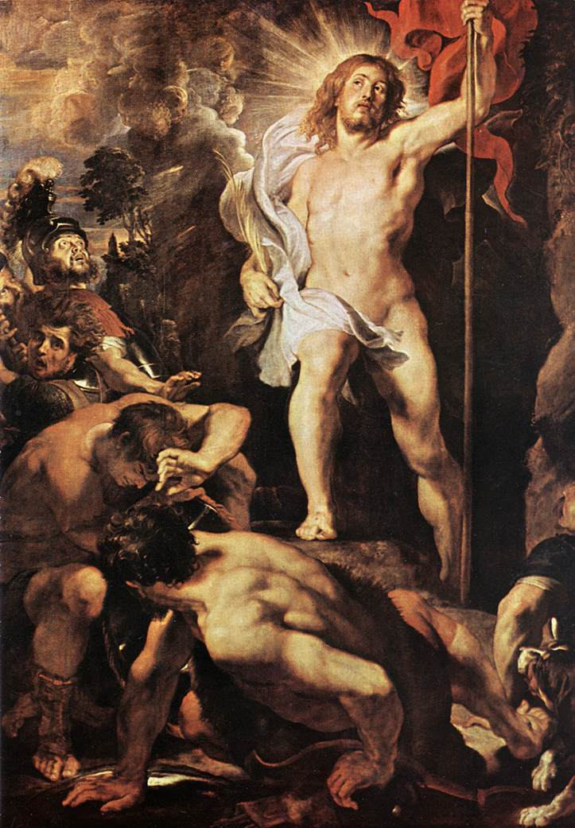

April 11, 2020

“Proclamation
of
Profitable
Rest”

The Presider and the deacon enter from the Sacristy. They reverence the Altar and stand in front of it, facing the people.

Acclamation
Presider: Blessed be the Holy, Eternal, and Undivided Trinity: Father, Son, and Holy Spirit.
People: And blessed be His glorious Kingdom, tonight and always, throughout all ages. Amen.

Collect of the Day
Presider: The Lord be with you.
People: And with your spirit.
Presider: Let us pray.
Miter off
O God, Creator of heaven and earth:
Grant that, as the crucified body of your dear Son was laid in the tomb and rested on His holy Sabbath, so we may await with Him the coming of the third day, and rise with Him to newness of life;
Who now lives and reigns with You and the Holy Spirit, one God, forever and ever. Amen.

Liturgy of the Word
Please be seated
First Proclamation
Proclaimer: A Proclamation of the Word of God from the book of the Prophet Job, Chapter Fourteen.
Job 14: 1-14
Proclaimer: The Word of the Lord.
People: Thanks be to God!
Responsorial Psalm: Psalm 118: 14 - 24
Proclaimer: The Lord is my strength and song, and He has become my salvation.
People: The sound of joyful shouting and salvation is in the tents of the righteous; the right hand of the Lord does valiantly.
Proclaimer: The right hand of the Lord is exalted; the right hand of the Lord does valiantly.
People: I shall not die, but live, and tell of the works of the Lord.
Proclaimer: The Lord has disciplined me severely, but He has not given me over to death.
People: Open to me the gates of righteousness; I shall enter through them, I shall give thanks to the Lord.
Proclaimer: This is the gate of the Lord; the righteous will enter through it.
People: I shall give thanks to You, for You have answered me; and You have become my salvation.
Proclaimer: The stone which the builders rejected has become the chief cornerstone.
People: This is the Lord’s doing; it is marvelous in our eyes.
Proclaimer: This is the day which the Lord has made;
People: Let us rejoice and be glad in it.
Proclaimer: Glory to the Father, and to the Son, and to the Holy Spirit;
People: As it was in the beginning, is now, and will be forever. Amen.
Please be seated
Second Proclamation
Proclaimer: A Proclamation of the Word of God from the First letter of St. Peter, Chapter Four.
1 Peter 4: 1-8
The proclaimer reads the second appointed lesson of the day.
Proclaimer: The Word of the Lord.
People: Thanks be to God!
Please stand.
Miter On. Bless the Gospel Proclaimer.
Gospel Acclamation
Miter Off.
Deacon: The Lord be with you.
People: And with your spirit.
Deacon: May the Lord be on our minds, on our lips, and on our hearts as we hear His Holy Gospel.
The Holy Gospel of our Lord Jesus Christ according to Saint John, Chapter Twenty.
People: Glory to You, Lord Christ!

Gospel Proclamation
The appointed Gospel is read by a Deacon.
John 20:1-19
Deacon: The Gospel of the Lord.
People: Praise to You, Lord Christ!

Please be seated
Reflection
Please stand

Hymn:
Christ the Lord is Risen Today

1) Christ the Lord is risen today, Hallelujah!
Sons of men and angels say: Hallelujah!
Raise your joys and triumphs high, Hallelujah!
Sing, ye heavens, and earth reply: Hallelujah!

2) Lives again our glorious King, Hallelujah! Hallelujah!
Where, O death, is now thy sting? Hallelujah! Hallelujah!
Dying once, He all doth save, Hallelujah! Hallelujah!
Where thy victory, O grave? Hallelujah!

3) Love’s redeeming work is done, Hallelujah!
Fought the fight, the battle won, Hallelujah!
Death in vain forbids Him rise, Hallelujah!
Christ has opened paradise, Hallelujah!

4) Soar we now where Christ has led, Hallelujah!
Following our exalted Head, Hallelujah!
Made like Him, like Him we rise, Hallelujah!
Ours the cross, the grave, the skies. Hallelujah!

Easter Vigil Proclamation (Exultet)
Deacon: The Lord be with you.
People: And with your spirit.
Deacon: Lift up your hearts.
People: We lift them up to the Lord.
Deacon: Let us give thanks unto our Lord God.
People: It is right to give Him thanks and praise.
Deacon: It is truly right that with full hearts and minds and voices we should praise the unseen God, the all-powerful Father, and His only Son, our Lord Jesus Christ.
People: Blessed be God forever.
Deacon: For Christ has ransomed us with His Blood, and paid for us the price of Adam’s sin to our Eternal Father.
People: Blessed be God forever.
Deacon: This is our Passover Feast, when Christ, the true Lamb, is slain, whose Blood consecrates the homes of all believers.
People: Blessed be God forever.
Deacon: This is the night when You first saved our fathers: You freed the people of Israel from their slavery and led them dry-shod through the sea.
People: Blessed be God forever.
Deacon: This is the night when Christians everywhere, washed clean of sin and freed from all defilement, are restored to grace and grow together in holiness.
People: Blessed be God forever.
Deacon: This is the night when Jesus Christ broke the chains of death and rose triumphant from the grave.
People: Blessed be God forever.
Deacon: What good would life have been to us, if Christ had not come as our Redeemer?
People: Blessed be God forever.
Deacon: Father, how wonderful is Your care for us! How boundless is Your merciful love! To ransom a slave, You gave up Your Son.
People: Blessed be God forever.
Deacon: O happy fault, O necessary sin of Adam, which gained for us so great a Redeemer!
People: Blessed be God forever.
Deacon: Of this night Scripture says, “Your night will be clear as day, it will become my light, my joy.”
People: Blessed be God forever.
Deacon: The power of this holy night dispels all evil, washes guilt away, restores lost innocence, brings mourners joy; it casts out hatred, brings us peace, and humbles earthly pride.
People: Blessed be God forever.
Deacon: Night truly blessed when Heaven is wedded to earth, and man is reconciled to God!
People: Blessed be God forever.

Miter on
Concluding Prayer
Presider: Almighty Father, may our hearts accept this Resurrection Gospel, a truth that stands eternally to the glory of God.
As it resounds through the halls of Heaven, so may our lives reflect its power here on earth, continuously burning to dispel the darkness of this night.
May Christ’s new life inspire our hearts and minds, kindling in us a holy desire to live with the power of Christ’s rising, and to finally feast at the heavenly banquet; through Jesus Christ our Lord, Who lives and reigns forever and ever.
All: Amen.

Commissioning
Deacon: Let us go forth in the Name of Christ.
All: Thanks be to God! Amen.

