ORDER
OF THE
HOLY MASS

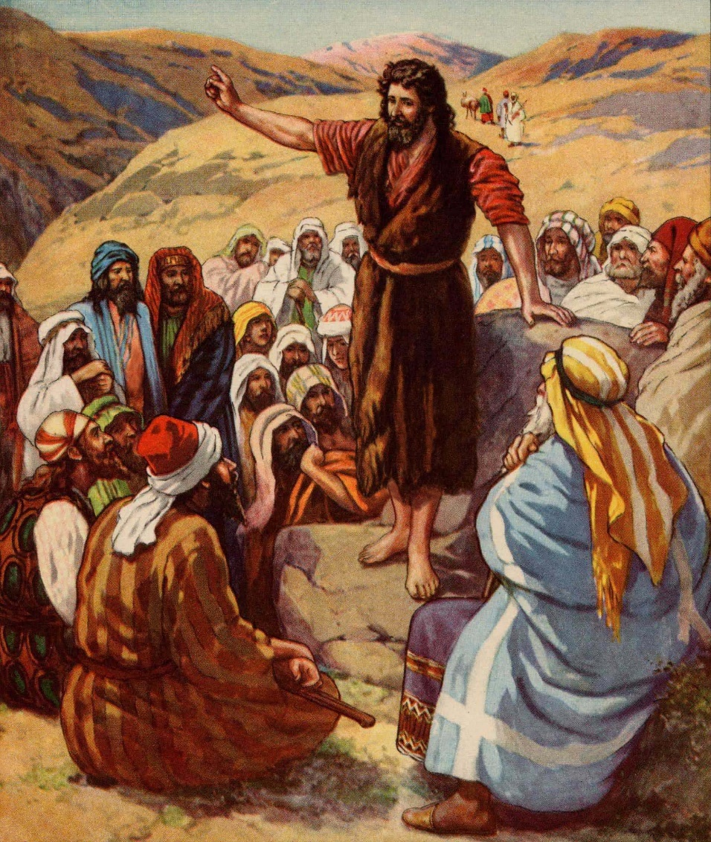
Advent

“Steadfast
in
Faith”

First Sunday of Advent
November 29, 2020

Processional
Please stand

HOLY IS THE LORD
(Fr. Dino Jorvina; c. Cathedral of the King)

Verse)
Holy is the Lord! God eternal we adore;
He is Wonderful, Counselor,
Mighty God, Everlasting Father, the Prince of Peace.
He reigns forever; He comes to save.

Chorus)
Holy! Holy! Holy is the Lord!

Bridge)
There’s a voice in the wilderness crying,
“Prepare the way of the Lord!
Every valley shall be exalted,
every lofty hill brought low;
And the glory of the Lord shall be revealed,
and all flesh shall see, see it!”

End)
Holy is the Lord!!!
Acclamation
The Ministers face the Presider, while the Presider faces the people and proclaims:
Presider: Bless the Lord Who forgives all our sins;
People: His mercy endures forever. Amen.
Collect for Purity
Presider: Let us pray.
Clergy face the Altar. Miter off.
Almighty God, to You all hearts are open,
all desires known, and from You no secrets are hid.
Cleanse the thoughts of our hearts
by the inspiration of Your Holy Spirit,
that we may perfectly love You
and worthily magnify Your holy Name;
through Christ our Lord.

All: Amen.

Penitential Rite
The Decalogue is spoken by the Deacon and the people.
Deacon faces the people.
Decalogue

Deacon: And God spoke all these words: I am the Lord your God, who brought you out of Egypt, out of the land of slavery. You shall have no other gods before Me.
People: Lord, have mercy upon us, and incline our hearts to keep this law.
Deacon: You shall not make for yourself an idol in the form of anything in Heaven above or on the earth beneath or in the waters below. You shall not bow down to them or worship them.
People: Lord, have mercy upon us, and incline our hearts to keep this law.
Deacon: You shall not misuse the Name of the Lord Your God, for the LORD will not hold anyone guiltless who misuses His Name.
People: Lord, have mercy upon us, and incline our hearts to keep this law.
Deacon: Remember the Sabbath day by keeping it holy.
People: Lord, have mercy upon us, and incline our hearts to keep this law.
Deacon: Honor your father and your mother.
People: Lord, have mercy upon us, and incline our hearts to keep this law.

Deacon: You shall not murder.
People: Lord, have mercy upon us, and incline our hearts to keep this law.
Deacon: You shall not commit adultery.
People: Lord, have mercy upon us, and incline our hearts to keep this law.
Deacon: You shall not steal.
People: Lord, have mercy upon us, and incline our hearts to keep this law.
Deacon: You shall not give false testimony against your neighbor.
People: Lord, have mercy upon us, and incline our hearts to keep this law.
Deacon: You shall not covet your neighbor's house, or anything that belongs to your neighbor."
People: Lord, have mercy upon us, and write these Your laws in our hearts.
Deacon: Brethren, let us acknowledge our sins, and so prepare ourselves to celebrate the sacred mysteries.

Deacon faces the Altar. All kneel. Deacon leads the prayer, in unison:

Confession
All: Most merciful God, I confess that I have sinned against You in thought, word, and deed, by what I have done, and by what I have left undone. I have not loved You with my whole heart; I have not loved my neighbor as myself. I am truly sorry and I humbly repent. For the sake of Your Son Jesus Christ, have mercy on me and forgive me; that I may delight in Your will, and walk in Your ways, to the glory of Your Name. Amen.

Absolution
Presider faces the people.
Presider: Almighty God have mercy on you, forgive you all your sins through our Lord Jesus Christ, strengthen you in all goodness, and by the power of the Holy Spirit keep you in eternal life.
All: Amen.
Please stand

Advent Hymn

THERE'S A VOICE IN THE WILDERNESS CRYING

1) There's a voice in the wilderness crying,
A call from the ways untrod;
Prepare in the desert a highway, a highway for our God!
The valleys shall be exalted, the lofty hills brought low;
Make straight all the crooked places
Where the Lord, our God, may go!

2) O Zion, that bringest good tidings,
Get thee up to the heights and sing!
Proclaim to a desolate people the coming of their King.
Like the flowers of the field they perish,
like grass our works decay;
The power and pomp of nations shall pass like a dream away.

3) But the Word of our God endureth,
the arm of the Lord is strong!
He stands in the midst of nations, and He will right the wrong.
He shall feed His flock like a shepherd,
the lambs He'll gently hold;
To pastures of peace He'll lead them,
and bring them safe to His fold.

Collect of the Day Proper 1st CEC
Presider faces the people.
Presider: The Lord be with you.
People: And with your spirit.
Presider: Let us pray.
Presider and Ministers face the Altar.
The Collect of the Day is taken from the appointed Proper for that day.
Presider: Almighty God, give us grace to cast away the works of darkness, and put on the armor of light, now in the time of this mortal life in which Your Son Jesus Christ came to visit us in great humility; that in the last day, when He shall come again in his glorious majesty to judge both the living and the dead, we may rise to the life immortal; through Him Who lives and reigns with You and the Holy Spirit, one God, now and forever.
All: Amen.
Presider goes to the back of the Altar, kisses it, and goes to his chair.
Please be seated

Liturgy of the Word
Please be seated
First Proclamation
Proclaimer: A Proclamation of the Word of God from the Book of the Prophet Isaiah, Chapter Sixty-Four

Isaiah 64: 1-9

Proclaimer: The Word of the Lord.
People: Thanks be to God!

Responsorial Psalm:
Psalm 80: 1-7

Proclaimer: Please stand for the Responsorial Psalm, which is taken from Psalm Eighty
All stand and the Proclaimer leads the people in the Responsorial Psalm followed by the Gloria Patri.
Proclaimer: Oh, give ear, Shepherd of Israel, You who lead Joseph like a flock; You who are enthroned above the cherubim, shine forth!
Proclaimer: Before Ephraim and Benjamin and Manasseh, stir up Your power and come to save us!
Proclaimer: O God, restore us and cause Your face to shine upon us, and we will be saved.
Proclaimer: O Lord God of hosts, how long will You be angry with the prayer of Your people?
Proclaimer: You have fed them with the bread of tears, and You have made them to drink tears in large measure.
Proclaimer: You make us an object of contention to our neighbors, and our enemies laugh among themselves.
Proclaimer: O God of hosts, restore us and cause Your face to shine upon us, and we will be saved.

Gloria Patri (BCP, Rite II)
The Gloria Patri may be spoken or sung in unison. The Proclaimer and Altar Ministers remain in their places, face the Altar, and bow.
All: Glory to the Father, and to the Son, and to the Holy Spirit:
As it was in the beginning, is now, and will be forever. Amen.

Please be seated.
Please be seated
Second Proclamation
Proclaimer: A Proclamation of the Word of God from …
1 Corinthians 1: 1-9
The proclaimer reads the second appointed lesson of the day.
Proclaimer: The Word of the Lord.
People: Thanks be to God!
Please stand.
Gradual Verse
Proclaimer: I wait for the Lord, My soul does wait, and in His Word do I hope; You art my hiding place and my shield, I wait for Your Word.
Miter On. Bless the Gospel Proclaimer.

GRADUAL: THY WORD (instrumental)
Gospel Acclamation
Miter Off.
Deacon: The Lord be with you.
People: And with your spirit.
Deacon: May the Lord be on our minds, on our lips, and on our hearts as we hear His Holy Gospel.
The Holy Gospel of our Lord Jesus Christ according to Saint Mark, Chapter Thirteen
People: Glory to You, Lord Christ!

Gospel Proclamation
The appointed Gospel is read by a Deacon.
Mark 13: 33-37
Deacon: The Gospel of the Lord.
People: Praise to You, Lord Christ!
All sit.
Homily
Please stand

Nicene Creed
All: We believe in one God, the Father Almighty, Maker of Heaven and earth, and of all things: visible and invisible.
And in one Lord, Jesus Christ, the only begotten Son of God, begotten of His Father before all worlds;
God of God, Light of Light, very God of very God
begotten, not made, being of one substance with the Father;
by Whom all things were made;
Who for us men and for our salvation came down from Heaven;
and was incarnate by the Holy Spirit and the Virgin Mary, and was made man;
And was crucified also for us under Pontius Pilate;
He suffered death and was buried, and rose again on the third day, in accordance with the Scriptures;
and ascended into Heaven, and is seated on the right hand of the Father;
and He shall come again, with glory, to judge the living and the dead;
Whose Kingdom shall have no end.
And we believe in the Holy Spirit the Lord, and Giver of Life, Who proceeds from the Father;
Who with the Father and the Son together is worshiped and glorified;
Who has spoken through the prophets.
And we believe one holy catholic and apostolic Church;
We acknowledge one baptism for the remission of sins;
and we look for the resurrection of the dead, and the life of the world to come. Amen.

Prayers of the People Form I (CEC)
The Deacon begins the Prayers of the People. The Minister continues.
Deacon: Dearly beloved brethren, the Lord always acts on behalf of the one who waits for Him. Let us beseech Him on behalf of those who are in need of restoration.
Minister: Faithful God, come to those who suffer because of war, disease, poverty, flood, or famine;
People: Come with deliverance, O Lord!
Minister: Come to those who suffer because of oppression, greed, and unrighteousness;
People: Come with recompense, O Lord!
Minister: Come to those who desire to return to You;
People: Come with mercy, O Lord!
Minister: Come to those who strive to obey Your Word and await Your promise;
People: Come with fulfillment, O Lord!
Minister: Come to those who, in response to Your promise, pray our Corporate Petition;
People: Come with greater things, O Lord!
Corporate Petition
Almighty God and King,
our dwelling place in all generations,
owner of the earth and all it contains:
Grant unto us our allotted inheritance, we pray,
and the grace to build upon it
facilities in which Your people,
being restored in Your image
and ever-growing in love for You,
might become a habitation of Your presence
and ministers of Your life,
to the glory of Jesus Christ our Lord;
Who lives and reigns together with You
and the Holy Spirit, one God,
now and forever. Amen.

Concluding Collect

Presider: Hasten, O Father, the fulfillment of Your Kingdom, and grant that we Your servants, who now live by faith, may with joy behold Your Son at His coming in glorious majesty; even Jesus Christ, our only Mediator and Advocate, in Whose Name we pray.
All: Amen.

Peace

Presider: The peace of the Lord be always with you.

People: And with your spirit.
Presider: Let us offer one another a sign of God’s peace.

Offertory
Presider gives the Offering Exhortation.

Worship in Psalms,
Hymns,
and Spiritual Songs:
The Sacrifice
of Praise

The Offertory:
The Sacrifice
of Ourselves
THE LORD REIGNS
(Dan Stradwick;
©1980 Scripture in Song (Adm. by Maranatha! Music))

Chorus)
The Lord reigns! The Lord reigns! The Lord reigns!
Let the earth rejoice! Let the earth rejoice!
Let the earth rejoice!
Let the people be glad that our God reigns!
(Repeat)

1)
A fire goes before Him and burns up all His enemies;
The hills melt like wax at the presence of the Lord;
At the presence of the Lord!

2)
The heavens declare His righteousness,
the people see His glory,
For You, O Lord, are exalted over all the earth;
Over all the earth!

CODA)
Our God reigns! (2x)
GREAT ARE YOU LORD
(Jason Ingram, Leslie Jordan, and David Leonard;
©2013 Integrity's Praise! Music & Integrity's Alleluia! Music (both adm at EMICMGPublishing.com) & Sony/ATV Timber Publishing/West Main Music/Winsor Hill Music)

Verse)
You give life, You are love
You bring light to the darkness
You give hope, You restore
Every heart that is broken
Great are You, Lord

Chorus)
It's Your breath in our lungs
So we pour out our praise
We pour out our praise
It's Your breath in our lungs
So we pour out our praise
To You only

Bridge)
All the earth will shout
Your praise
Our hearts will cry
These bones will sing
Great are You, Lord

IT IS YOU
(Pete Sanchez, Jr.; c. Hosanna! Music)

It is You, it is You, it is You that I love;
It is You, my Lord and King,
I apprehend to know and be known.
You, it is You, it is You that I worship;
Holy! Holy! Worthy, yes, You're worthy!
How I love You, Lord!

CODA)
How I love You, Lord! (2x)

The Lesser Doxology may be sung in a high mass, during which time the Presider censes the gifts.
After the Altar and Gifts have been censes by the Presider, the Deacon censes the Ministers, then all of the people.
Then Presider censes the front of the Altar and the Ministers again.

Lesser Doxology
(Traditional)
(Words and Music By: Thomas Ken)
(Attributed To Louis Bourgeois)

Praise God from Whom all blessings flow,
Praise Him all creatures here below;
Praise Him above, ye heavenly Host:
Praise Father, Son and Holy Ghost!
AMEN!

Preparation of the Gifts
Standing behind the Altar, the Presider takes the paten with the bread or a large host, and, holding it slightly raised above the altar, says:
Presider: Blessed are You Lord, God of all creation. For through Your goodness we have received the bread we offer You: fruit of the earth and work of human hands, it will become the Body of Christ.
People: Blessed be God forever.
While pouring a small amount of water into the chalice and flagon, the Presider says quietly:
Presider: By the mystery of this water and wine may we come to share in the divinity of Christ, who humbled Himself to share in our humanity.
Then the Presider takes the chalice and, holding it slightly raised above the altar, says:
Presider: Blessed are You Lord, God of all creation, for through Your goodness we have received the wine we offer You, fruit of the vine and work of human hands; it will become the Blood of Christ.
People: Blessed be God forever.

Then the Presider takes an offering basket or bag, and while holding it slightly raised above the altar, says:
Presider: Blessed are You Lord, God of all creation, for through Your goodness we bring these tithes and offerings before You. They will be used in Your church for the work You have set before us and the furthering of Your kingdom.
Presider places the offering below the altar, then washes his hands, quietly saying:
Presider: Wash me, O Lord, from my iniquity and cleanse me from my sin.
Exhortation To Pray (Orate fratres)
The Presider returns to the center of the altar, faces the people, and says:
Presider: Pray, brothers and sisters, that our sacrifice may be acceptable to God, the Almighty Father.
People: May the Lord accept the sacrifice at your hands for the praise and glory of His name, for our good and the good of all His holy Church.
All: Amen.

Great Thanksgiving
Presider: The Lord be with you.
People: And with your spirit.
Presider: Lift up your hearts.
People: We lift them up to the Lord.
Presider: Let us give thanks to the Lord our God.
People: It is right to give Him thanks and praise.
Preface 1st Advent CEC
The priest continues the preface with hands extended:
Presider: It is truly right and just, our duty and our salvation, always and everywhere to give You thanks, Lord, holy Father, almighty and eternal God, through Christ our Lord.
For He assumed at his first coming the lowliness of human flesh, and so fulfilled the design You formed long ago, and opened for us the way to eternal salvation, that, when He comes again in glory and majesty and all is at last made manifest, we who watch for that day may inherit the great promise in which now we dare to hope.
And so, with angels and archangels, with thrones and dominions, and with all the hosts and powers of heaven, we sing the hymn of Your glory, as without end we acclaim:

Sanctus Benedictus

Eucharistic Prayer IV CEC
Presider: Holy and gracious Father, in Your infinite love You made us for Yourself, and when we had fallen into sin and become subject to evil and death, You, in Your mercy sent Jesus Christ, Your only and eternal Son, to share our human nature, to live and die as one of us, to reconcile us to You, the God and Father of all.
He stretched out his arms on the cross and offered himself, in obedience to Your will, a perfect sacrifice for the whole world.

Epiclesis
Please kneel
The Presider joins his hands, then, holding them outstretched over the offerings, says:
Presider: And so, Father, we pray that, in Your goodness and mercy, Your Holy Spirit may descend upon us and upon these gifts, sanctifying them and showing them to be holy gifts for Your holy people, the bread of life and the cup of salvation,
The Presider joins his hands, then makes the sign of the cross once over both bread and chalice, and says:
Presider: the Body and Blood of Your Son, Jesus Christ.
Anamnesis
Presider: On the night He was handed over to suffering and death, our Lord Jesus Christ took bread; and when He had given thanks to You, He broke it, gave it to his disciples, and said,
“Take, eat: this is My body, which is for you; do this in remembrance of Me.”

The Presider shows the consecrated host to the people, places it on the paten, and bows or genuflects in adoration.
Presider: After supper He took the cup of wine, and when He had given thanks, He gave it to them and said:
“Drink this, all of you. This is My Blood of the New Covenant, which is shed for you and for many for the forgiveness of sins. Whenever you drink it, do this for the remembrance of Me.”

(The Presider shows the consecrated chalice to the people, places it on the corporal, and bows or genuflects in adoration.)
(Please stand)
Presider: Father, we now celebrate this memorial of our redemption. Recalling Christ’s death and his descent among the dead, proclaiming his resurrection and ascension to Your right hand, and awaiting his coming in glory; and offering to You from the gifts You have given us, this bread and this cup, we give You praise as we proclaim the mystery of faith:

Mysterium Fidei

All: Christ has died, Christ is risen, Christ will come again!

Oratio Pro Ecclessia

Presider: Grant that all who share this bread and cup may become one body and one spirit, a living sacrifice to the praise of Your Name.

Remember, Lord, Your one holy catholic and apostolic Church, redeemed by the blood of Jesus. Reveal its unity, guard its faith, and preserve it in peace.

Remember Craig, our Patriarch, Ariel our bishop, and all who minister in Your church and teach the true faith that comes to us from the apostles.

Remember those for whom we now pray: _____

Presider: And grant that we may find our inheritance with the Blessed Virgin Mary, with Joseph her husband, with patriarchs, prophets, apostles, and martyrs, and all the saints who have found favor with You in ages past. We praise You in union with them and give You glory through Your Son Jesus Christ our Lord.

The Presider takes the chalice and the host and, lifting them up, says:
Presider: By Him, with Him, and in Him, in the unity of the Holy Spirit, all honor and glory is Yours, almighty Father, now and forever.

All: Amen.

The Presider continues:
Presider: And now as our Savior Christ taught us, we are bold to pray.

THE LORD’S PRAYER
(Samuel Thurman)

Our Father, Who art in heaven,
Hallowed be Thy Name;
Thy kingdom come;
Thy will be done on earth as it is in heaven.
Give us this day our daily bread.
And forgive us our trespasses,
As we forgive those who trespass against us.
And lead us not into temptation.
But deliver us from evil.
For Thine is the Kingdom and the power
And the glory forever, forever, forever, forever.
AMEN.

Breaking of the Bread
The Presider breaks the consecrated host in half, then breaks off a small piece and places it in the chalice.
Lamb of God (Agnus Dei)
The Agnus Dei is spoken or said in Advent rather than the Pascha Nostrum.

Invitation to Communion
The Presider elevates the host and the chalice together, saying:
Presider: Behold the Lamb of God, behold Him Who takes away the sin of the world. Blessed are those called to the Supper of the Lamb.
People: Lord, I am not worthy that You should enter under my roof, but say only the word and my soul shall be healed.
Presider: The gifts of God for the people of God:
Take them in remembrance that Jesus died for you, and feed on Him in your hearts with thanksgiving.

Prayer for Receiving Spiritual Communion

All: My Jesus, I believe that You are present in the Most Holy Sacrament. I love You above all things, and I desire to receive You into my soul.
Since I cannot at this moment receive You sacramentally, come at least spiritually into my heart. I embrace You as if You are already there, and unite myself wholly to You. Never permit me to be separated from You. Amen.

The Ministration of Communion
O CHILD OF PROMISE COME

Post-Communion Prayer
Presider: Let us pray.
All: Almighty and everliving God, we thank You for feeding us with the spiritual food of the most precious Body and Blood of Your Son, our Savior Jesus Christ; and for assuring us in these holy mysteries that we are living members of the Body of Your Son, and heirs of Your eternal kingdom.
And now, Father, send us out to do the work You have given us to do, to love and serve You as faithful witnesses of Christ our Lord.
To him, to You, and to the Holy Spirit, be honor and glory, now and forever. Amen.
Blessing
Miter on.
Bishop: The Lord be with you.
People: And with your spirit.
Bishop: Our help is in the Name of the Lord.
People: The maker of heaven and earth.

Deacon: Bow your heads and pray for God’s blessing.
Presider: May He Whose second coming in power and great glory we await make you steadfast in faith, joyful in hope, and constant in love; and the blessing of God Almighty, the Father and the Son and the Holy Spirit be with you this day and forever.

Recessional
LIFT UP YOUR HEADS
(Steve Fry; c. Birdwing Music)

Lift up your heads to the coming King.
Bow before Him and adore Him, sing!
To His majesty let your praises be,
Pure and holy, giving glory to the King of kings.

END) Pure and holy, giving glory to the King of kings.
Dismissal
Deacon: Go in peace glorifying the Lord by your life.
People: Thanks be to God. Hallelujah! Hallelujah! Amen.

